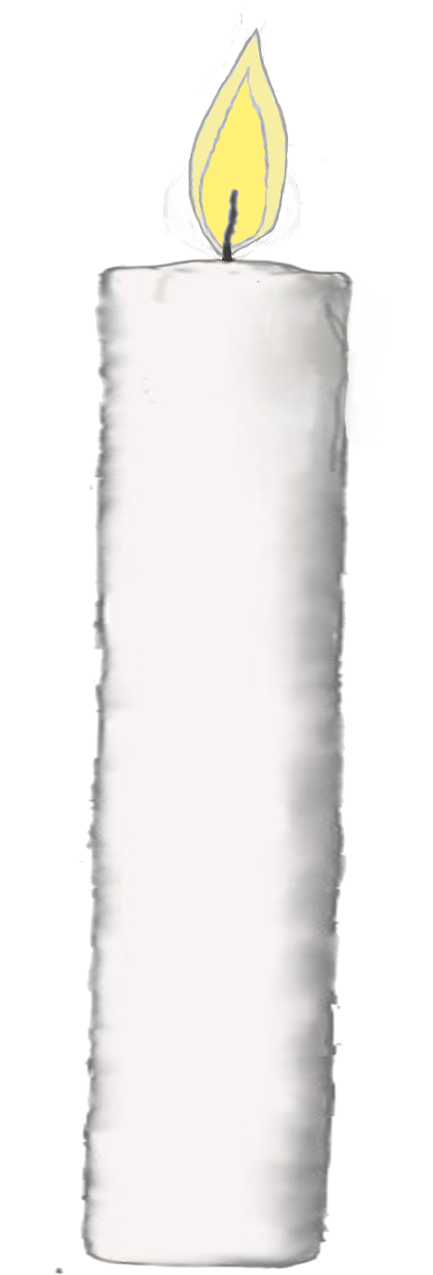

Take this opportunity to pause and remember those who are no longer with us.

Sunday 8th December 2024

at 4.30pm

Merrow Methodist church

From Loss to Light