COFFEE MORNING FOR

AL-AHLI HOSPITAL – GAZA
(The oldest and only Christian Hospital)

Thursday 10th September
Coffee and Cakes from 10.30am
at Merrow Methodist Church
Talk by Dr Ang Swee Chai at 11.30am

A Senior Consultant at Barts Hospital. She has worked as a surgeon in both Gaza and Lebanon and has spoken at the United Nations. She is a founder member on the Board of MAP (Medical Aid for Palestinians).

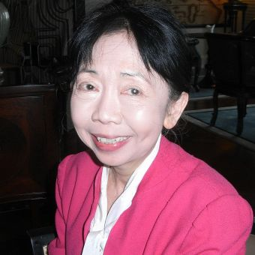
Please come and listen to this wonderful, courageous lady who has worked tirelessly against injustice.

